# Annexure 4

# Subject- First Minutes of Meeting Regarding the Discussion on Society Formation

**Topic**- STEP DTU Society Formation Meeting

**Date & Time**-23rd January 2022, Sunday, 1700 Hours.

# People Present:

* Dr. T. Vijaya Kumar, Faculty Advisor
* Vaibhav Anand, President
* Shivam Bilandi, Vice President
* Stuti Jain, Joint Secretary
* Kanjam Manocha, Joint Secretary
* Ashutosh Chauhan, General Secretary
* Sanyam Maheshwari , Treasurer
* Saif Ali, Design Head
* Jai Aggarwal, Event Management Head
* Nilesh Yadav, Event Management Head
* H A Pavan Kashyap, Technical Head
* Ritika Sawhney Saha, Content Head
* Vibhor Gautam, Student Advisor
* Jasmeer Singh, Student Advisor

**Item 1:** Finalising Name of The Society and Discussing the Bylaws.

**Item 2:** Had a brief introduction of every member by themselves and were allotted their role in the society.

**Item 3:** Had a discussion on society basis its aim and objective.

**Item 4:** Discussed the documentation work that will be required in the Bank account and Society domain formation and work was compartmentalized accordingly.

**Item 5:** Discussed the formation of the society logo.

**Item 6:** Discussed the future of society like Online& Offline Events, recruitment, etc and step to be taken for that.

**Signature of the Present People**

1. Dr. T. Vijaya Kumar, Faculty Advisor
2. Vaibhav Anand (2k20/CO/472) A close-up of a logo

   Description automatically generated with low confidence

1. Shivam Bilandi (2K20/BT/58), 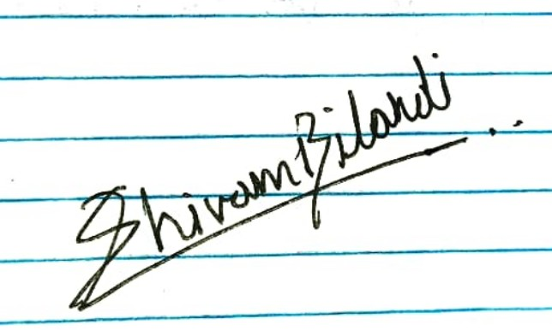
2. Stuti Jain (2K20/ME/280), 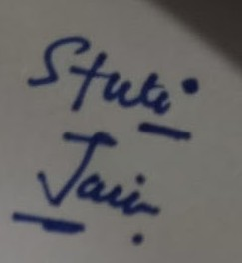

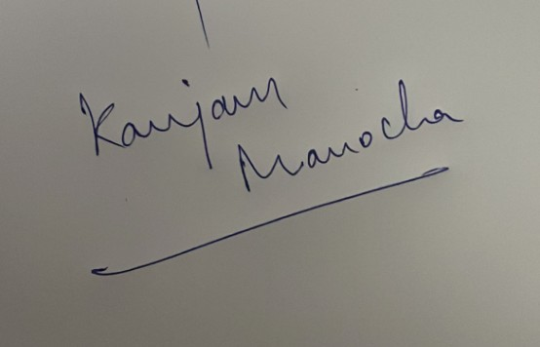

1. Kanjam Manocha (2K20/BT/27)

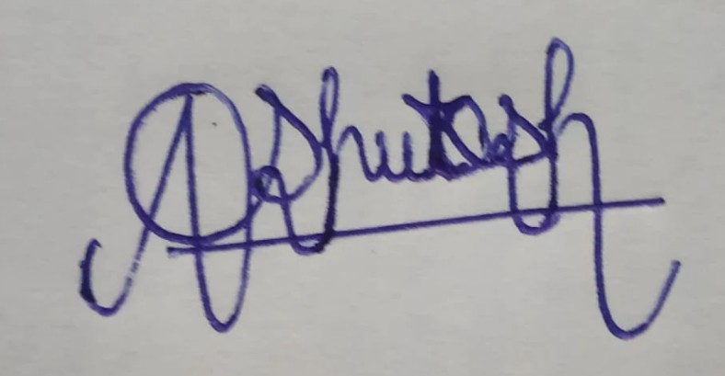

1. Ashutosh Chauhan (2K20/BT/15)
2. Sanyam Maheshwari (2K20/IT/129) 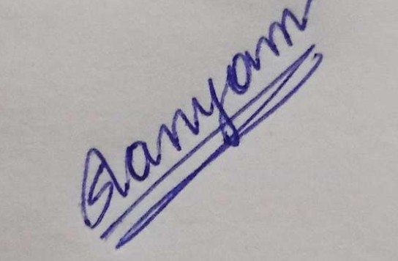
3. Vibhor Gautam (2K19/EC/207) 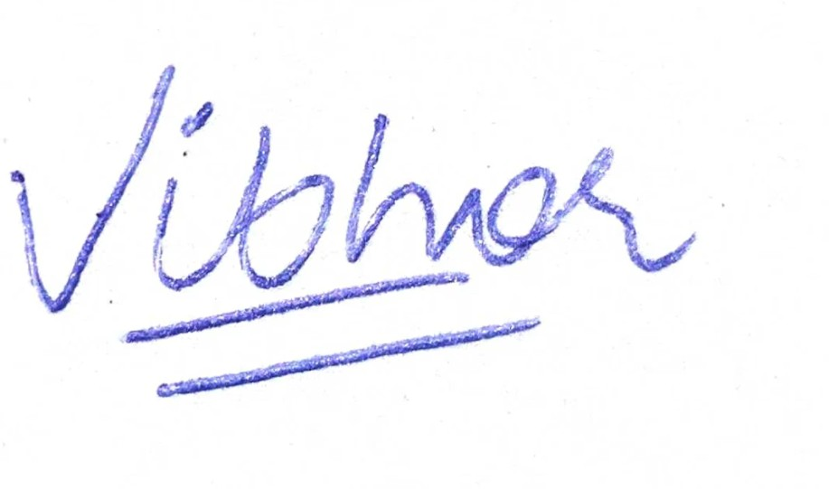
4. Jasmeer Singh (2K20/BT/509), 
5. Saif Ali (2K20/BT/50) 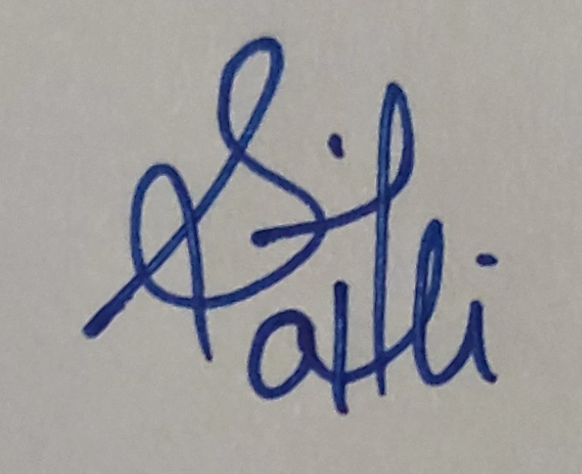

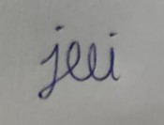

1. Jai Aggarwal (2K20/CO/208)
2. Nilesh Yadav (2K20/BT/35 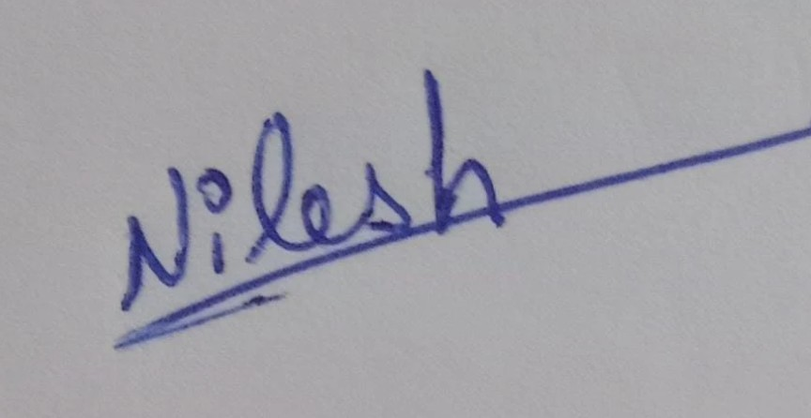
3. H A Pavan Kashyap (2K20/CO/178) 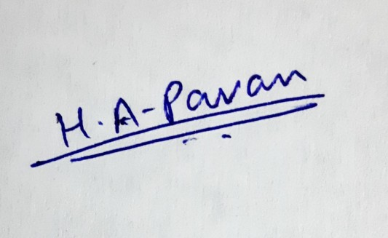
4. Ritika Sawhney Saha (2K20/BT/48) 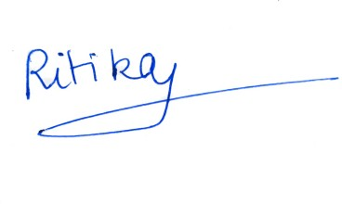

**Annexure 5**

# Subject- Undertaking of No Disciplinary Action Pending Against Office Bearers of STEP DTU

We, the office bearers of “STEP DTU” solemnly declare that we are not part of any disciplinary action pending or convicted by the university. We, also acknowledge that if we submit or produce any false information and it is later discovered then we shall be liable under the Bylaws for the time being in force.

The above statements have been made by us, in our senses, and are true to the best of our knowledge and belief.

Yours Faithfully,

Office Bearers of STEP DTU.

All Office Bearers names mentioned with Name, Roll Number and Signature in Continuation.

**Annexure 3**

# Subject: Consent Letter for Membership of STEP DTU

We, the members of the student society STEP DTU, hereby consent to the society’s

establishment and all future activities. We also undertake the responsibility to manage and conduct society’s events and meetings as per the bylaws of our society.

We all consent to be a member of STEP DTU society and undertake the responsibility to manage and conduct society’s events and meetings as per the bylaws of the society.

We will ensure to abide by the guidelines always approved by the University.

Yours Faithfully,  
Founding Members of STEP DTU.

Name, Address & Student I-Card attached in continuation.

Date-

To

Dean Student Welfare,

Delhi Technological University, Shahbad Daulatpur,

Main Bawana Road,

Delhi-110042. *Through Faculty Advisor*

# Subject- Request For Establishment Of Student Society- “STEP DTU”

Respected Ma’am,

We, the students at Delhi Technological University, wish to propose the idea of establishing a society that aims to work with the mission of harnessing continued happiness & harmony under all circumstances. It will promote the art of happiness scientifically through education, research activities, collaborations with industry professionals and other stakeholders. We will execute various measures in the domain of well-being, happiness, and spiritual awareness leading to evolution. Our vision is to develop innovative tools for personal & organizational growth with the help of researchers from academic and spiritual institutes. Through these tools, we will imbibe & nurture compassion, loyalty, and good interpersonal relations. Research shows that happy people are productive and, in this regard, DTU has already taken a lot of initiatives like establishing a Centre of Excellence for the Science of Happiness and Foundation Elective Course (FEC) on Happiness, etc. For the upliftment of our department, we propose to establish STEP DTU Delhi Technological University, under faculty advisor Dr. T. Vijaya Kumar. We request you to approve the formation of the society. Please find enclosed the constitution for STEP DTU

Thanking You

Yours Sincerely,

Vaibhav Anand(2k20/CO/472) Shivam Bilandi(2k20/BT/58)

Co-Founder Co-Founder